MODULE – IV
Data-Intensive Computing: MapReduce Programming

Data-intensive computing focuses on a class of applications that deal with a large amount of data. Several application fields, ranging from computational science to social networking, produce large volumes of data that need to be efficiently stored, made accessible, indexed, and analyzed. Distributed computing is definitely of help in addressing these challenges by providing more scalable and efficient storage architectures and a better performance in terms of data computation and processing.
This chapter characterizes the nature of data-intensive computing and presents an overview of the challenges introduced by production of large volumes of data and how they are handled by storage systems and computing models. It describes MapReduce, which is a popular programming model for creating data-intensive applications and their deployment on clouds.

What is data-intensive computing?
Data-intensive computing is concerned with production, manipulation, and analysis of large-scale data in the range of hundreds of megabytes (MB) to petabytes (PB) and beyond.
Dataset is commonly used to identify a collection of information elements that is relevant to one or more applications. Datasets are often maintained in repositories, which are infrastructures supporting the storage, retrieval, and indexing of large amounts of information.
To facilitate classification and search, relevant bits of information, called metadata, are attached to datasets. Data-intensive computations occur in many application domains.
Computational science is one of the most popular ones. People conducting scientific simulations and experiments are often keen to produce, analyze, and process huge volumes of data. Hundreds of gigabytes of data are produced every second by telescopes mapping the sky; the collection of images of the sky easily reaches the scale of petabytes over a year.
Bioinformatics applications mine databases that may end up containing terabytes of data.
Earthquake simulators process a massive amount of data, which is produced as a result of recording the vibrations of the Earth across the entire globe.

Characterizing data-intensive computations
Data-intensive applications deals with huge volumes of data, also exhibit compute-intensive properties. Figure 4.1 identifies the domain of data-intensive computing in the two upper quadrants of the graph. Data-intensive applications handle datasets on the scale of multiple terabytes and petabytes.
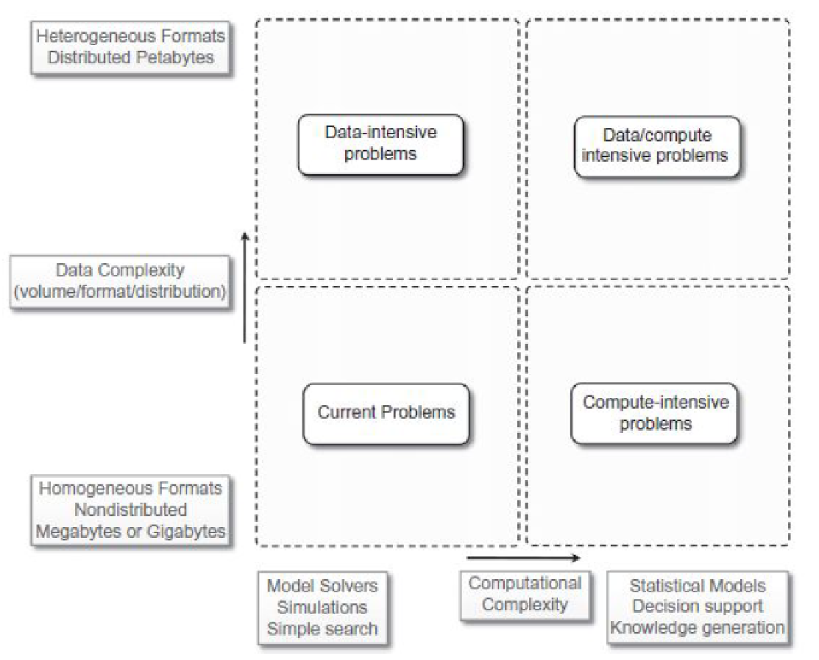
Figure 4.1: Data intensive research issues
Challenges ahead
The huge amount of data produced, analyzed, or stored imposes requirements on the supporting infrastructures and middleware that are hardly found in the traditional solutions. Moving terabytes of data becomes an obstacle for high-performing computations.
Data partitioning, content replication and scalable algorithms help in improving the performance.
Open challenges in data-intensive computing given by Ian Gorton et al. are:
1. Scalable algorithms that can search and process massive datasets.
2. New metadata management technologies that can handle complex, heterogeneous, and distributed data sources.
3. Advances in high-performance computing platforms aimed at providing a better support for accessing in-memory multi-terabyte data structures.
4. High-performance, highly reliable, petascale distributed file systems.
5. Data signature-generation techniques for data reduction and rapid processing.
6. Software mobility that are able to move the computation to where the data are located.
7. Interconnection architectures that provide better support for filtering multi gigabyte data streams coming from high-speed networks and scientific instruments.
8. Software integration techniques that facilitate the combination of software modules running on different platforms to quickly form analytical pipelines.

Historical perspective
Data-intensive computing involves the production, management, and analysis of large volumes of data. Support for data-intensive computations is provided by harnessing storage, networking, technologies, algorithms, and infrastructure software all together.
The early age: high-speed wide-area networking
In 1989, the first experiments in high-speed networking as a support for remote visualization of scientific data led the way. Two years later, the potential of using high-speed wide area networks for enabling high-speed, TCP/IP-based distributed applications was demonstrated at Supercomputing 1991 (SC91).
Data grids
Huge computational power and storage facilities could be obtained by harnessing heterogeneous resources across different administrative domains. Data grids emerge as infrastructures that support data-intensive computing. A data grid provides services that help users discover, transfer, and manipulate large datasets stored in distributed repositories as well as create and manage copies of them.
Data grids offer two main functionalities:
- High-performance and reliable file transfer for moving large amounts of data, and
- Scalable replica discovery and management mechanisms.
Data clouds and “Big Data”
Together with the diffusion of cloud computing technologies that support data-intensive computations, the term Big Data has become popular. Big Data characterizes the nature of data-intensive computations today and currently identifies datasets that grow so large that they become complex to work with using on-hand database management tools. In general, the term Big Data applies to datasets of which the size is beyond the ability of commonly used software tools to capture, manage, and process within a tolerable elapsed time. Therefore, Big Data sizes are a constantly moving target, currently ranging from a few dozen tera-bytes to many petabytes of data in a single dataset.
A data cloud is a combination of these components.
Ex 1: MapReduce framework, which provides the best performance for leveraging the Google File System on top of Google’s large computing infrastructure.
Ex 2: Hadoop system, the most mature, large, and open-source data cloud. It consists of the Hadoop Distributed File System (HDFS) and Hadoop’s implementation of MapReduce.
Ex 3: Sector, consists of the Sector Distributed File System (SDFS) and a compute service called Sphere that allows users to execute arbitrary user-defined functions (UDFs) over the data managed by SDFS.
Ex 4: Greenplum uses a shared-nothing massively parallel processing (MPP) architecture based on commodity hardware.

Databases and data-intensive computing
Distributed databases are a collection of data stored at different sites of a computer network. Each site might expose a degree of autonomy, providing services for the execution of local applications, but also participating in the execution of a global application. A distributed database can be created by splitting and scattering the data of an existing database over different sites or by federating together multiple existing databases. These systems are very robust and provide distributed transaction processing, distributed query optimization, and efficient management of resources.

Technologies for data-intensive computing
Data-intensive computing concerns the development of applications that are mainly focused on processing large quantities of data. Therefore, storage systems and programming models constitute a natural classification of the technologies supporting data-intensive computing.

Storage systems
Traditionally, database management systems constituted the de facto storage. Due to the explosion of unstructured data in the form of blogs, Web pages, software logs, and sensor readings, the relational model in its original formulation does not seem to be the preferred solution for supporting data analytics on a large scale.
Some factors contributing to change in database are:
A. Growing of popularity of Big Data. The management of large quantities of data is no longer a rare case but instead has become common in several fields: scientific computing, enterprise applications, media entertainment, natural language processing, and social network analysis.
B. Growing importance of data analytics in the business chain. The management of data is no longer considered a cost but a key element of business profit. This situation arises in popular social networks such as Facebook, which concentrate their focus on the management of user profiles, interests, and connections among people.
C. Presence of data in several forms, not only structured. As previously mentioned, what constitutes relevant information today exhibits a heterogeneous nature and appears in several forms and formats.
D. New approaches and technologies for computing. Cloud computing promises access to a massive amount of computing capacity on demand. This allows engineers to design software systems that incrementally scale to arbitrary degrees of parallelism.

High-performance distributed file systems and storage clouds
Distributed file systems constitute the primary support for data management. They provide an interface whereby to store information in the form of files and later access them for read and write operations.
a. Lustre. The Lustre file system is a massively parallel distributed file system that covers the needs of a small workgroup of clusters to a large-scale computing cluster. The file system is used by several of the Top 500 supercomputing systems. Lustre is designed to provide access to petabytes (PBs) of storage to serve thousands of clients with an I/O throughput of hundreds of gigabytes per second (GB/s). The system is composed of a metadata server that contains the metadata about the file system and a collection of object storage servers that are in charge of providing storage.
b. IBM General Parallel File System (GPFS). GPFS is the high-performance distributed file system developed by IBM that provides support for the RS/6000 supercomputer and Linux computing clusters. GPFS is a multiplatform distributed file system built over several years of academic research and provides advanced recovery mechanisms. GPFS is built on the concept of shared disks, in which a collection of disks is attached to the file system nodes by means of some switching fabric. The file system makes this infrastructure transparent to users and stripes large files over the disk array by replicating portions of the file to ensure high availability.
c. Google File System (GFS). GFS is the storage infrastructure that supports the execution of distributed applications in Google’s computing cloud.
GFS is designed with the following assumptions:
1. The system is built on top of commodity hardware that often fails.
2. The system stores a modest number of large files; multi-GB files are common and should be treated efficiently, and small files must be supported, but there is no need to optimize for that.
3. The workloads primarily consist of two kinds of reads: large streaming reads and small random reads.
4. The workloads also have many large, sequential writes that append data to files.
5. High-sustained bandwidth is more important than low latency. The architecture of the file system is organized into a single master, which contains the metadata of the entire file system, and a collection of chunk servers, which provide storage space. From a logical point of view the system is composed of a collection of software daemons, which implement either the master server or the chunk server.
d. Sector. Sector is the storage cloud that supports the execution of data-intensive applications defined according to the Sphere framework. It is a user space file system that can be deployed on commodity hardware across a wide-area network. The system’s architecture is composed of four nodes: a security server, one or more master nodes, slave nodes, and client machines.
e. Amazon Simple Storage Service (S3). Amazon S3 is the online storage service provided by Amazon. The system offers a flat storage space organized into buckets, which are attached to an Amazon Web Services (AWS) account. Each bucket can store multiple objects, each identified by a unique key. Objects are identified by unique URLs and exposed through HTTP, thus allowing very simple get-put semantics.
NoSQL systems
The term Not Only SQL (NoSQL) was coined in 1998 to identify a set of UNIX shell scripts and commands to operate on text files containing the actual data. NoSQL cannot be considered a relational database, it is a collection of scripts that allow users to manage most of the simplest and more common database tasks by using text files as information stores.
Two main factors have determined the growth of the NoSQL:
1. Simple data models are enough to represent the information used by applications, and
2. The quantity of information contained in unstructured formats has grown.
Let us now examine some prominent implementations that support data-intensive applications.
a. Apache CouchDB and MongoDB.
Apache CouchDB and MongoDB are two examples of document stores. Both provide a schema-less store whereby the primary objects are documents organized into a collection of key-value fields. The value of each field can be of type string, integer, float, date, or an array of values.
The databases expose a RESTful interface and represent data in JSON format. Both allow querying and indexing data by using the MapReduce programming model, expose JavaScript as a base language for data querying and manipulation rather than SQL, and support large files as documents.
b. Amazon Dynamo.
The main goal of Dynamo is to provide an incrementally scalable and highly available storage system. This goal helps in achieving reliability at a massive scale, where thousands of servers and network components build an infrastructure serving 10 million requests per day. Dynamo provides a simplified interface based on get/put semantics, where objects are stored and retrieved with a unique identifier (key). The architecture of the Dynamo system, shown in Figure 4.2, is composed of a collection of storage peers organized in a ring that shares the key space for a given application.

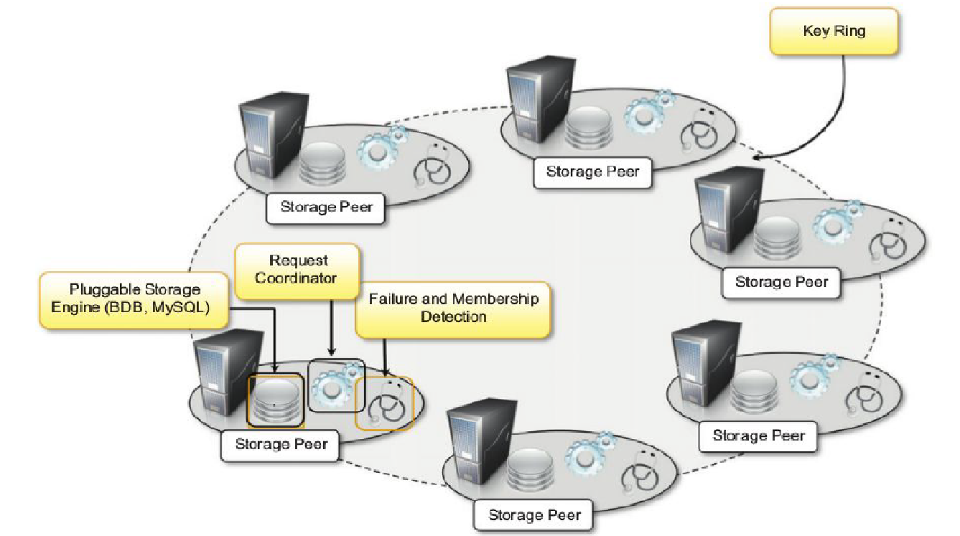
Figure 4.2: Amazon Dynamo architecture
The key space is partitioned among the storage peers, and the keys are replicated across the ring, avoiding adjacent peers. Each peer is configured with access to a local storage facility where original objects and replicas are stored.
c. Google Bigtable.
Bigtable provides storage support for several Google applications that expose different types of workload: from throughput-oriented batch-processing jobs to latency-sensitive serving of data to end users. Bigtable’s key design goals are wide applicability, scalability, high performance, and high availability. To achieve these goals, Bigtable organizes the data storage in tables of which the rows are distributed over the distributed file system supporting the middleware, which is the Google File System. Figure 4.3 gives an overview of the infrastructure that enables Bigtable. The service is the result of a collection of processes that coexist with other processes in a cluster-based environment. Bigtable identifies two kinds of processes: master processes and tablet server processes. A tablet server is responsible for serving the requests for a given tablet that is a contiguous partition of rows of a table. Each server can manage multiple tablets (commonly from 10 to 1,000). The master server is responsible for keeping track of the status of the tablet servers and of the allocation of tablets to tablet servers.
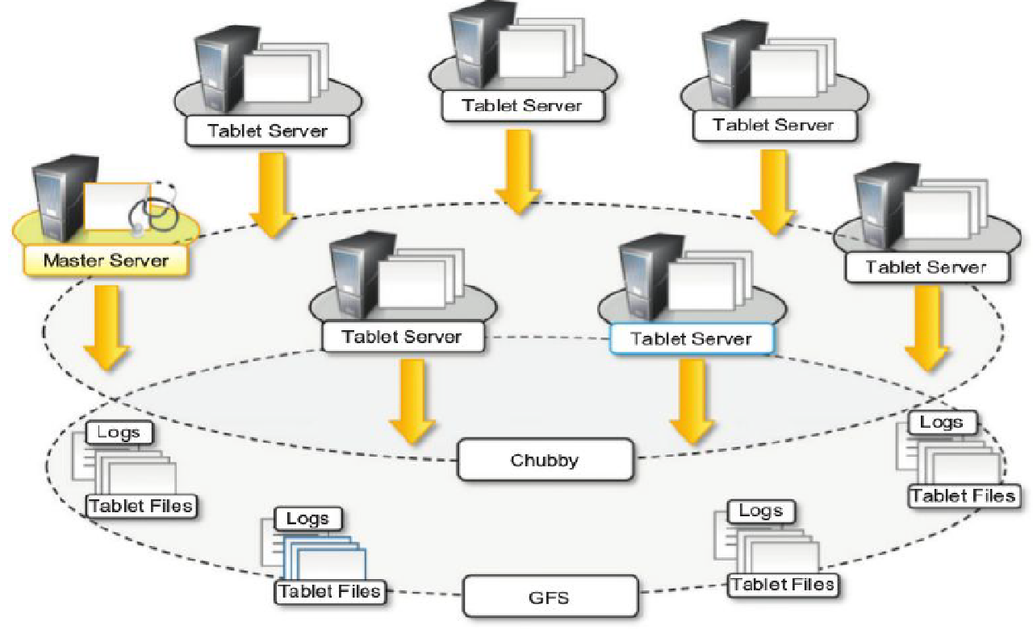
Figure 4.3: Bigtable architecture
d. Apache Cassandra.
The system is designed to avoid a single point of failure and offer a highly reliable service. Cassandra was initially developed by Facebook; now it is part of the Apache incubator initiative. Currently, it provides storage support for several very large Web applications such as Facebook itself, Digg, and Twitter. The data model exposed by Cassandra is based on the concept of a table that is implemented as a distributed multidimensional map indexed by a key.
e. Hadoop HBase.
HBase is designed by taking inspiration from Google Bigtable; its main goal is to offer real-time read/write operations for tables with billions of rows and millions of columns by leveraging clusters of commodity hardware. The internal architecture and logic model of HBase is very similar to Google Bigtable, and the entire system is backed by the Hadoop Distributed File System (HDFS).

Programming platforms
Programming platforms for data-intensive computing provide higher-level abstractions, which focus on the processing of data and move into the runtime system the management of transfers, thus making the data always available where needed. This is the approach followed by the MapReduce programming platform, which expresses the computation in the form of two simple functions—map and reduce—and hides the complexities of managing large and numerous data files into the distributed file system supporting the platform. In this section, we discuss the characteristics of MapReduce and present some variations of it.

The MapReduce programming model.
MapReduce expresses the computational logic of an application in two simple functions: map and reduce. Data transfer and management are completely handled by the distributed storage infrastructure (i.e., the Google File System), which is in charge of providing access to data, replicating files, and eventually moving them where needed. The MapReduce model is expressed in the form of the two functions, which are defined as follows:
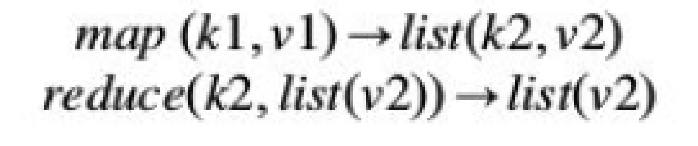
The map function reads a key-value pair and produces a list of key-value pairs of different types. The reduce function reads a pair composed of a key and a list of values and produces a list of values of the same type. The types (k1, v1, k2, kv2) used in the expression of the two functions provide hints as to how these two functions are connected and are executed to carry out the computation of a MapReduce job: The output of map tasks is aggregated together by grouping the values according to their corresponding keys and constitutes the input of reduce tasks that, for each of the keys found, reduces the list of attached values to a single value.

Figure 4.4 depicts a reference workflow characterizing MapReduce computations. As shown, the user submits a collection of files that are expressed in the form of a list of < k1, v1 > pairs and specifies the map and reduce functions. These files are entered into the distributed file system that supports MapReduce and, if necessary, partitioned in order to be the input of map tasks.

The computation model expressed by MapReduce is very straightforward and allows greater productivity for people who have to code the algorithms for processing huge quantities of data.
In general, any computation that can be expressed in the form of two major stages can be represented in terms of MapReduce computation.
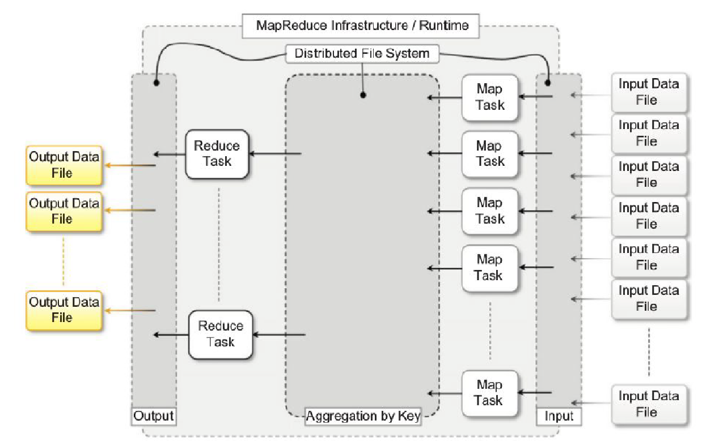
Figure 4.4: MapReduce computation workflow
These stages are:
1. Analysis. This phase operates directly on the data input file and corresponds to the operation performed by the map task. Moreover, the computation at this stage is expected to be embarrassingly parallel, since map tasks are executed without any sequencing or ordering.
2. Aggregation. This phase operates on the intermediate results and is characterized by operations that are aimed at aggregating, summing, and/or elaborating the data obtained at the previous stage to present the data in their final form. This is the task performed by the reduce function.
Figure 4.5 gives a more complete overview of a MapReduce infrastructure, according to the implementation proposed by Google. As depicted, the user submits the execution of MapReduce jobs by using the client libraries that are in charge of submitting the input data files, registering the map and reduce functions, and returning control to the user once the job is completed.

A generic distributed infrastructure (i.e., a cluster) equipped with job-scheduling capabilities and distributed storage can be used to run MapReduce applications. Two different kinds of processes are run on the distributed infrastructure:
A master process and
A worker process.
The master process is in charge of controlling the execution of map and reduce tasks, partitioning, and reorganizing the intermediate output produced by the map task in order to feed the reduce tasks.
The master process generates the map tasks and assigns input splits to each of them by balancing the load. The worker processes are used to host the execution of map and reduce tasks and provide basic I/O facilities that are used to interface the map and reduce tasks with input and output files.
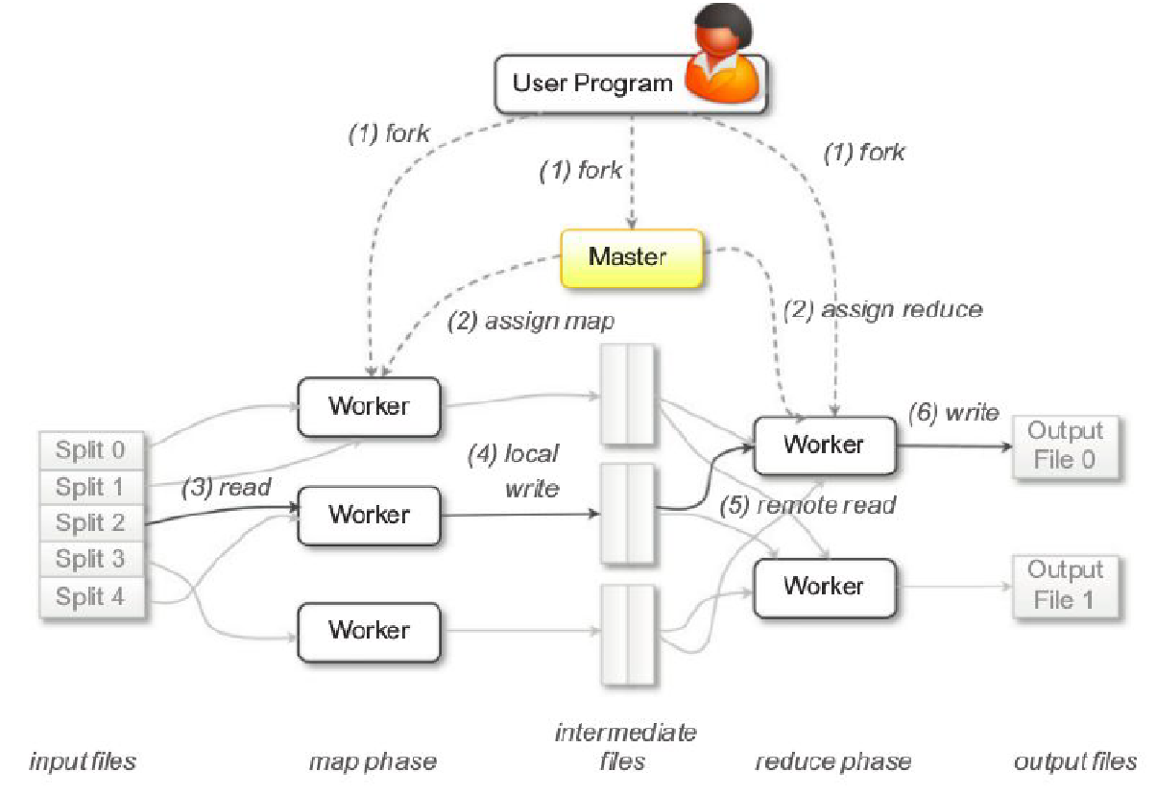
Figure 4.5: Google MapReduce infrastructure overview

Variations and extensions of MapReduce
MapReduce constitutes a simplified model for processing large quantities of data and imposes constraints on the way distributed algorithms should be organized to run over a MapReduce infrastructure. Therefore, a series of extensions to and variations of the original MapReduce model have been proposed. They aim at extending the MapReduce application space and providing developers with an easier interface for designing distributed algorithms. We briefly present a collection of MapReduce-like frameworks and discuss how they differ from the original MapReduce model.
A. Hadoop.
B. Pig.
C. Hive.
D. Map-Reduce-Merge.
E. Twister.
A. Hadoop.
Apache Hadoop is a collection of software projects for reliable and scalable distributed computing. The initiative consists of mostly two projects: Hadoop Distributed File System (HDFS) and Hadoop MapReduce. The former is an implementation of the Google File System; the latter provides the same features and abstractions as Google MapReduce.
B. Pig.
Pig is a platform that allows the analysis of large datasets. Developed as an Apache project, Pig consists of a high-level language for expressing data analysis programs, coupled with infrastructure for evaluating these programs. The Pig infrastructure’s layer consists of a compiler for a high-level language that produces a sequence of MapReduce jobs that can be run on top of distributed infrastructures.
C. Hive.
Hive is another Apache initiative that provides a data warehouse infrastructure on top of Hadoop MapReduce. It provides tools for easy data summarization, ad hoc queries, and analysis of large datasets stored in Hadoop MapReduce files. Hive’s major advantages reside in the ability to scale out, since it is based on the Hadoop framework, and in the ability to provide a data warehouse infrastructure in environments where there is already a Hadoop system running.
D. Map-Reduce-Merge.
Map-Reduce-Merge is an extension of the MapReduce model, introducing a third phase to the standard MapReduce pipeline—the Merge phase—that allows efficiently merging data already partitioned and sorted (or hashed) by map and reduce modules. The Map-Reduce-Merge framework simplifies the management of heterogeneous related datasets and provides an abstraction able to express the common relational algebra operators as well as several join algorithms.
E. Twister.
Twister is an extension of the MapReduce model that allows the creation of iterative executions of MapReduce jobs. With respect to the normal MapReduce pipeline, the model proposed by Twister proposes the following extensions:
1. Configure Map
2. Configure Reduce
3. While Condition Holds True Do
a. Run MapReduce
b. Apply Combine Operation to Result
c. Update Condition
4. Close
Twister provides additional features such as the ability for map and reduce tasks to refer to static and in-memory data; the introduction of an additional phase called combine, run at the end of the MapReduce job that aggregates the output together.
Alternatives to MapReduce.
a. Sphere.
b. All-Pairs.
c. DryadLINQ.
a. Sphere.
Sphere is the distributed processing engine that leverages the Sector Distributed File System (SDFS). Sphere implements the stream processing model (Single Program, Multiple Data) and allows developers to express the computation in terms of user-defined functions (UDFs), which are run against the distributed infrastructure. Sphere is built on top of Sector’s API for data access.

UDFs are expressed in terms of programs that read and write streams. A stream is a data structure that provides access to a collection of data segments mapping one or more files in the SDFS. The execution of UDFs is achieved through Sphere Process Engines (SPEs), which are assigned with a given stream segment.
b. All-Pairs.
It provides a simple abstraction—in terms of the All-pairs function—that is common in many scientific computing domains: All-pairs(A:set; B:set; F:function) -> M:matrix
Ex 1: field of biometrics, where similarity matrices are composed as a result of the comparison of several images that contain subject pictures.
Ex 2: applications and algorithms in data mining.
c. DryadLINQ.
Dryad is a Microsoft Research project that investigates programming models for writing parallel and distributed programs to scale from a small cluster to a large datacenter. In Dryad, developers can express distributed applications as a set of sequential programs that are connected by means of channels.
Aneka MapReduce programming
Introducing the MapReduce programming model
The MapReduce Programming Model defines the abstractions and runtime support for developing MapReduce applications on top of Aneka. Figure 4.6 provides an overview of the infrastructure supporting MapReduce in Aneka. The application instance is specialized, with components that identify the map and reduce functions to use. These functions are expressed in terms of Mapper and Reducer classes that are extended from the Aneka MapReduce APIs.
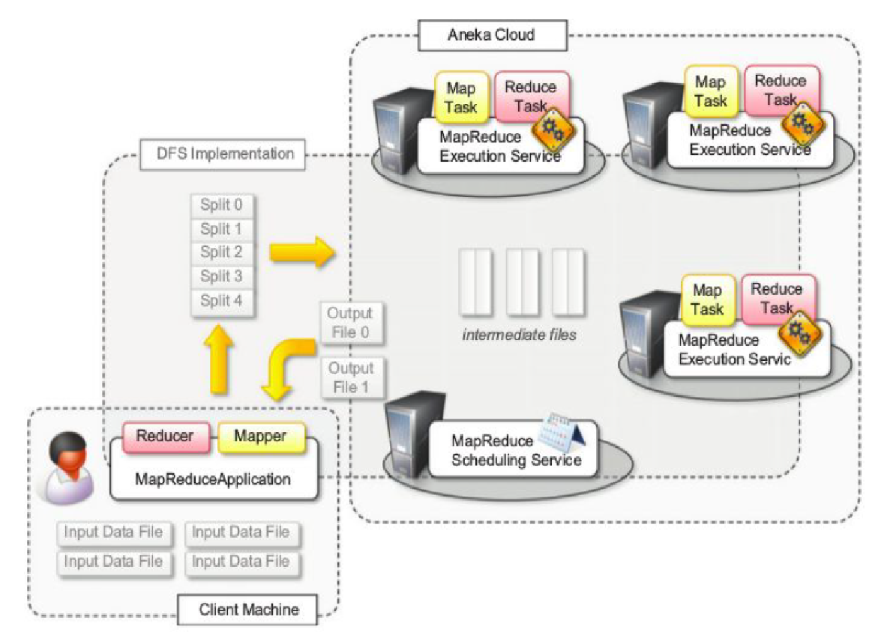
Figure 4.6: Aneka MapReduce infrastructure
The runtime support is composed of three main elements:
1. MapReduce Scheduling Service, which plays the role of the master process in the Google and Hadoop implementation.
2. MapReduce Execution Service, which plays the role of the worker process in the Google and Hadoop implementation.
3. A specialized distributed file system that is used to move data files. Client components, namely the MapReduce Application, are used to submit the execution of a MapReduce job, upload data files, and monitor it.
Programming abstractions
Aneka executes any piece of user code within distributed application. The task creation is responsibility of the infrastructure once the user has defined the map and reduce functions. Therefore, the Aneka MapReduce APIs provide developers with base classes for developing Mapper and Reducer types and use a specialized type of application class—Map Reduce Application - that supports needs of this programming model.
Figure 4.7 provides an overview of the client components defining the MapReduce programming model. Three classes are of interest for application development: Mapper<K, V>, Reducer<K, V>, and MapReduce Application<M, R>.
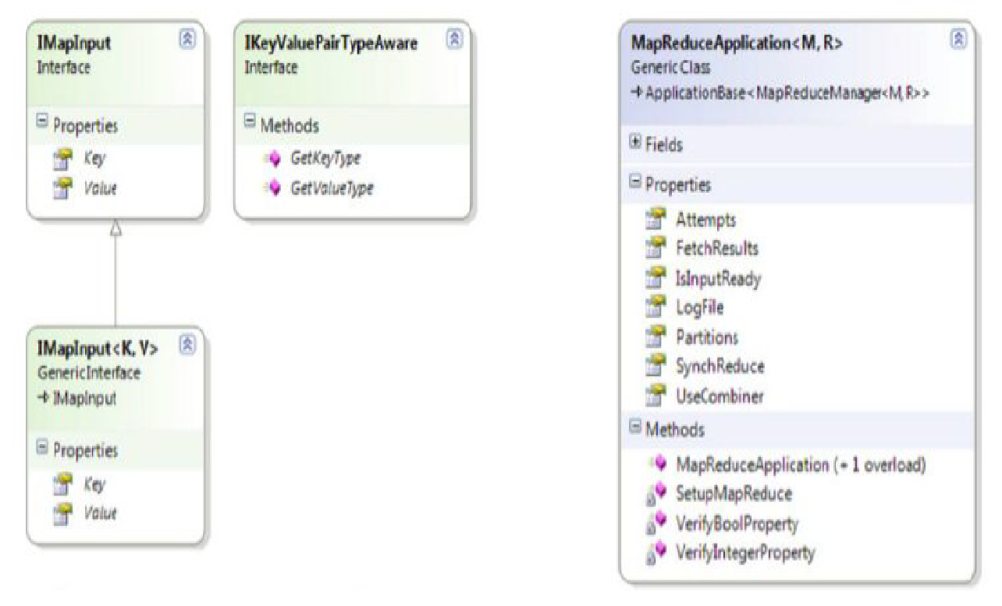
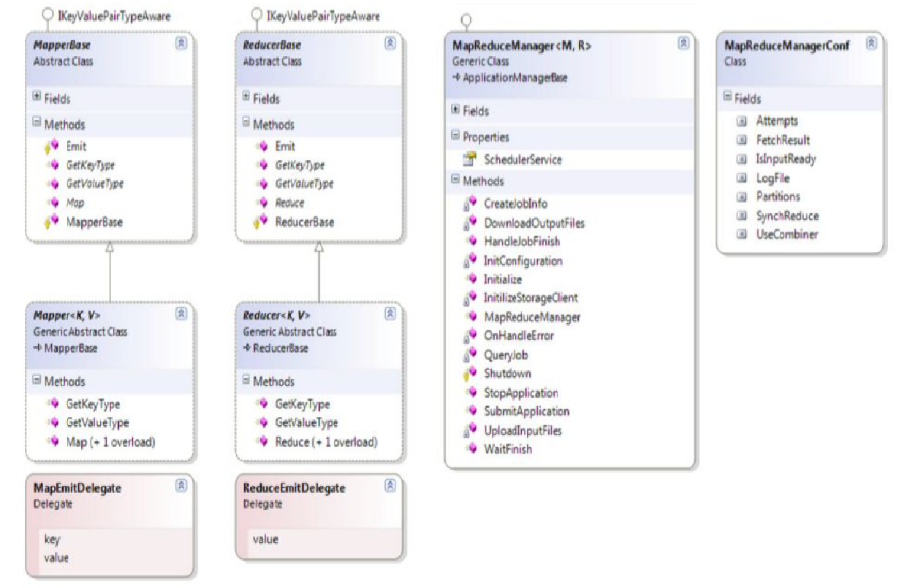
Figure 4.7: MapReduce Abstractions Object model

using Aneka.MapReduce.Internal;
namespace Aneka.MapReduce
{
/// Interface IMapInput<K,V>. Extends IMapInput and provides strongly-typed version of extended
/// interface.
public interface IMapInput<K,V>: IMapInput
{
/// Property <i>Key</i> returns the key of key/value pair.
K Key { get; }
/// Property <i>Value</i> returns the value of key/value pair.
V Value { get; }
}
……
LISTING 4.1 Map Function APIs.
using Aneka.MapReduce;
namespace Aneka.MapReduce.Examples.WordCounter
{
/// Class WordCounterMapper. Extends Mapper<K,V> and provides an
/// implementation of the map function for the Word Counter sample.
public class WordCounterMapper: Mapper<long,string>
{
/// Reads the source and splits into words. For each of the words found
/// emits the word as a key with a vaue of 1.
protected override void Map(IMapInput<long,string> input)
{
// we don’t care about the key, because we are only interested on
// counting the word of each line.
string value = input.Value;
string[] words = value.Split(" \t\n\r\f\"\'|!-=()[]<>:{}.#".ToCharArray(),
StringSplitOptions.RemoveEmptyEntries);
// we emit each word without checking for repetitions. The word becomes
// the key and the value is set to 1, the reduce operation will take care
// of merging occurrences of the same word and summing them.
foreach(string word in words)
{
this.Emit(word, 1);
}
}
}
}
…..
Some more listings can be referred from text book.
Runtime support
The runtime support for the execution of MapReduce jobs comprises the collection of services that deal with scheduling and executing MapReduce tasks.
These are the MapReduce Scheduling Service and the MapReduce Execution Service.
Job and Task Scheduling. The scheduling of jobs and tasks is the responsibility of the MapReduce Scheduling Service, which covers the same role as the master process in the Google MapReduce implementation. The architecture of the Scheduling Service is organized into two major components: the MapReduceSchedulerService and the MapReduceScheduler. Main role of the service wrapper is to translate messages coming from the Aneka runtime or the client applications into calls or events directed to the scheduler component, and vice versa.
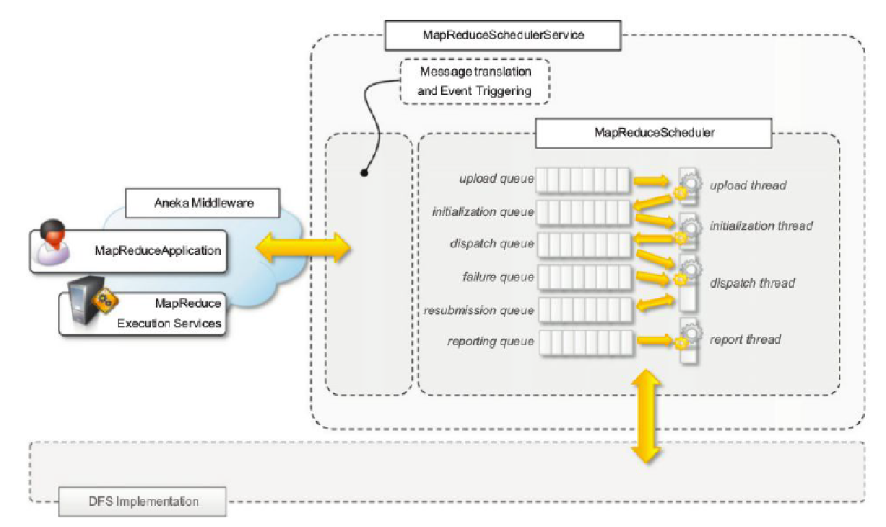
Figure 4.8: MapReduce scheduling service architecture
The relationship of the two components is depicted in Figure 4.8 (as shown above) the core functionalities for job and task scheduling are implemented in the MapReduceScheduler class. The scheduler manages multiple queues for several operations, such as uploading input files into the distributed file system; initializing jobs before scheduling; scheduling map and reduce tasks; keeping track of unreachable nodes; resubmitting failed tasks; and reporting execution statistics.

Task Execution.
The execution of tasks is controlled by the MapReduce Execution Service. This component plays the role of the worker process in the Google MapReduce implementation. The service manages the execution of map and reduce tasks and performs other operations, such as sorting and merging intermediate files. The service is internally organized, as described in Figure 4.9.
There are three major components that coordinate together for executing tasks:
1. MapReduce- SchedulerService,
2. ExecutorManager, and
3. MapReduce Executor.
The MapReduce Scheduler Service interfaces the ExecutorManager with the Aneka middleware; the ExecutorManager is in charge of keeping track of the tasks being executed by demanding the specific execution of a task to the MapReduce Executor and of sending the statistics about the execution back to the Scheduler Service.
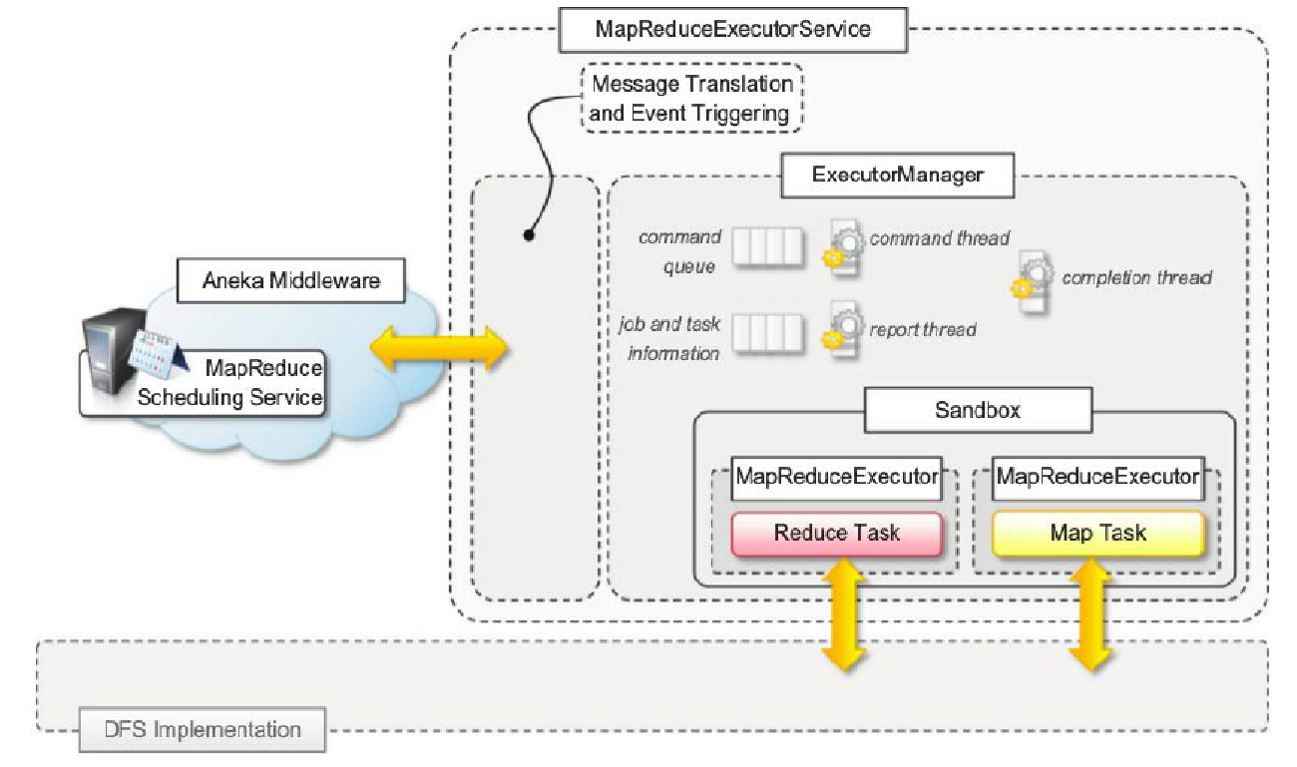
Figure 4.9: MapReduce execution service architecture
Distributed file system support
Aneka supports, the MapReduce model that uses a distributed file system implementation. Distributed file system implementations guarantee high availability and better efficiency by means of replication and distribution. The original MapReduce implementation assumes the existence of a distributed and reliable storage; hence, the use of a distributed file system for implementing the storage layer is natural. Aneka provides the capability of interfacing with different storage implementations and it maintains the same flexibility for the integration of a distributed file system.
The level of integration required by MapReduce requires the ability to perform the following tasks:
- Retrieving the location of files and file chunks
- Accessing a file by means of a stream
The first operation is useful to the scheduler for optimizing the scheduling of map and reduce tasks according to the location of data; the second operation is required for the usual I/O operations to and from data files. On top of these low-level interfaces, MapReduce programming model offers classes to read from and write to files in a sequential manner. These are classes SeqReader and SeqWriter. They provide sequential access for reading and writing key-value pairs, and they expect specific file format, which is described in Figure 4.10.
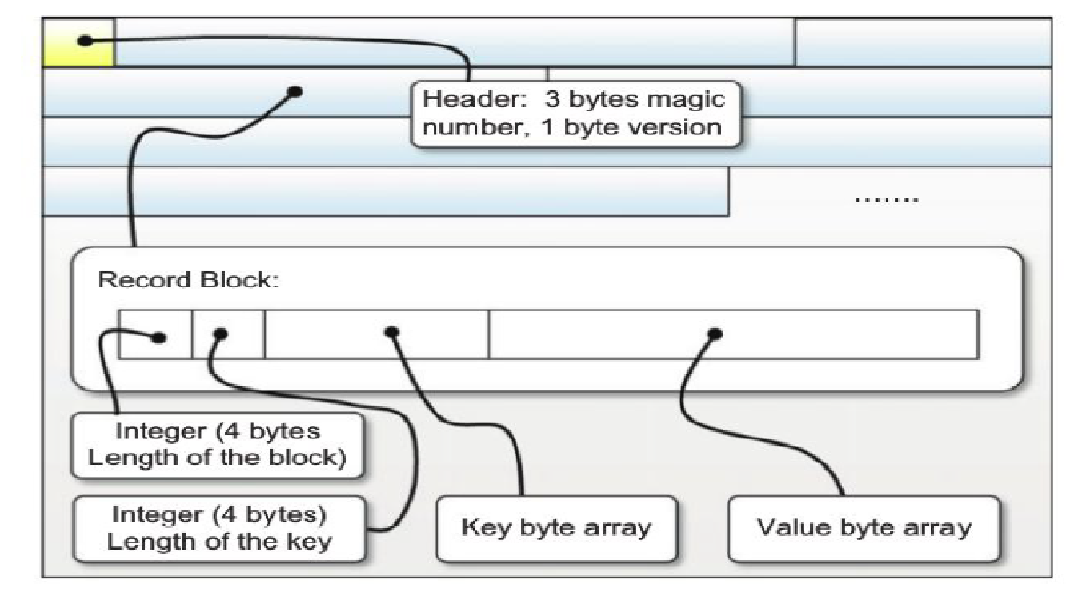
Figure 4.10: Aneka MapReduce data file format
Example application
To demonstrate how to program real applications with Aneka MapReduce, we consider a very common task: log parsing. We design a MapReduce application that processes the logs produced by the Aneka container in order to extract some summary information about the behavior of the Cloud.
Parsing Aneka logs
Aneka components produce a lot of information that is stored in the form of log files. In this example, we parse these logs to extract useful information about the execution of applications and the usage of services in the Cloud.
The entire framework leverages the log4net library for collecting and storing the log information.
Some examples of formatted log messages are:
15 Mar 2011 10:30:07 DEBUGSchedulerService: . . .
HandleSubmitApplicationSchedulerService: . . .
15 Mar 2011 10:30:07 INFOSchedulerService: Scanning candidate storage . . .
15 Mar 2011 10:30:10 INFOAdded [WU: 51d55819-b211-490f-b185-8a25734ba705,
4e86fd02. . .

.
.
.
Possible information that we might want to extract from such logs is the following:
- The distribution of log messages according to the level
- The distribution of log messages according to the components

This information can be easily extracted and composed into a single view by creating Mapper tasks that count the occurrences of log levels and component names and emit one simple key-value pair in the form (level-name, 1) or (component-name, 1) for each of the occurrences. The Reducer task will simply sum up all the key-value pairs that have the same key. For both problems, the structure of the map and reduce functions will be the following:
map: (long; string) => (string; long)
reduce: (long; string) => (string; long)
The Mapper class will then receive a key-value pair containing the position of the line inside the file as a key and the log message as the value component. It will produce a key-value pair containing a string representing the name of the log level or the component name and 1 as value. The Reducer class will sum up all the key-value pairs that have the same name.
Mapper design and implementation
The operation performed by the map function is a very simple text extraction that identifies the level of the logging and the name of the component entering the information in the log. Once this information is extracted, a key-value pair (string, long) is emitted by the function.
Listing 4.2 shows the implementation of the Mapper class for the log parsing task. The Map method simply locates the position of the log-level label into the line, extracts it, and emits a corresponding key-value pair (label, 1).
using Aneka.MapReduce;
namespace Aneka.MapReduce.Examples.LogParsing
{
/// Class LogParsingMapper. Extends Mapper<K,V> and provides an
/// implementation of the map function for parsing the Aneka container log files .
/// This mapper emits a ke y-value (log-level, 1) and potentially another key -value
/// (_aneka -component-name,1) if it is able to extract such information from the
/// input.
public class LogParsingMapper: Mapper<long,string>
{
/// Reads the input and extracts the information about the log level and if
/// found the name of the aneka component that entered the log line .
protected override void Map(IMapInput<long,string>input)
{
// we don’t care about the key, because we are only interested on
// counting the word of each line.
string value = input.Value;
long quantity = 1;
// first we extract the log level name information. Since the date is reported
// in the standard format DD MMM YYYY mm:hh:ss it is possible to skip the first
// 20 characters (plus one space) and then extract the next following characters
// until the next position of the space character.
int start = 21;
int stop = value.IndexOf( ' ', start);
string key = value.Substring(start, stop – start);
this.Emit(key, quantity);
//now we are looking for the Aneka component name that entered the log line
//if this is inside the log line it is just right after the log level preceeded
//by the character sequence <space><dash><space> and terminated by the <c olon> character.
start = stop + 3; // we skip the <space><dash><space> sequence.
stop = value.IndexOf( ':', start);
key = value.Substring(start, stop – start);
// we now check whether the key contains any space, if not then it is the name
// of an Aneka component and the line does not need to be skipped.
if (key.IndexOf(' ') == -1)
{
this.Emit("_" + key, quantity);
}
}
}
}
LISTING 4.2 Log-Parsing Mapper Implementation.
Reducer design and implementation
The implementation of the reduce function is even more straightforward; the only operation that needs to be performed is to add all the values that are associated to the same key and emit a key-value pair with the total sum.
Listing 4.3, the operation to perform is very simple and actually is the same for both of the two different key-value pairs extracted from the log lines.

using Aneka.MapReduce;
namespace Aneka.MapReduce.Examples.LogParsing
{
/// Class <b><i>LogParsingReducer</i></b>. Extends Reducer<K,V> and provides an
/// implementation of the redcuce function for parsing the Aneka container log files .
/// The Reduce method iterates all over values of the enumerator and sums the values
/// before emitting the sum to the output file.
public class LogParsingReducer : Reducer<string,long>
{
/// Iterates all over the values of the enum erator and sums up
/// all the values before emitting the sum to the output file.
protected override void Reduce(IReduceInputEnumerator<long>input)
{
long sum = 0;
while(input.MoveNext())
{
long value = input.Current;
sum += value;
}
this.Emit(sum);
}
}
}
LISTING 4.3 Aneka Log-Parsing Reducer Implementation.
Driver program
LogParsingMapper and LogParsingReducer constitute the core functionality of the MapReduce job, which only requires to be properly configured in the main program in order to process and produce text tiles. Another task that is performed in the driver application is the separation of these two statistics into two different files for further analysis.

Running the application
Aneka produces a considerable amount of logging information. The default configuration of the logging infrastructure creates a new log file for each activation of the Container process or as soon as the dimension of the log file goes beyond 10 MB. Therefore, by simply continuing to run an Aneka Cloud for a few days, it is quite easy to collect enough data to mine for our sample application.
In the execution of the test, we used a distributed infrastructure consisting of seven worker nodes and one master node interconnected through a LAN. We processed 18 log files of several sizes for a total aggregate size of 122 MB. The execution of the MapReduce job over the collected data produced the results that are stored in the loglevels.txt and components.txt files and represented graphically in Figures 4.11 and 4.12, respectively.
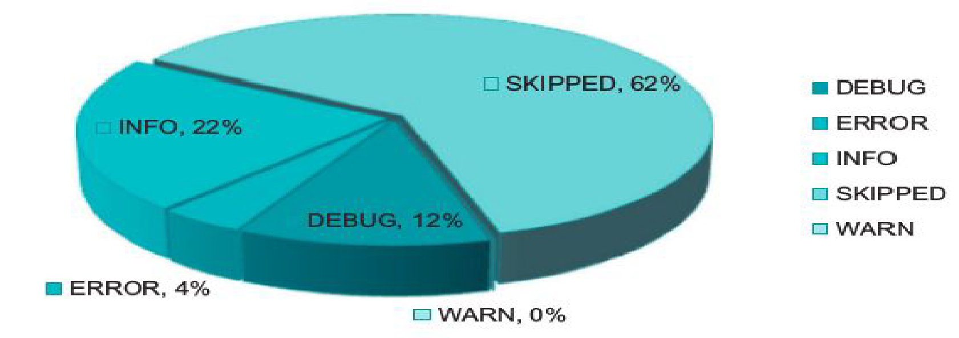
Figure 4.11: Log level entry distribution
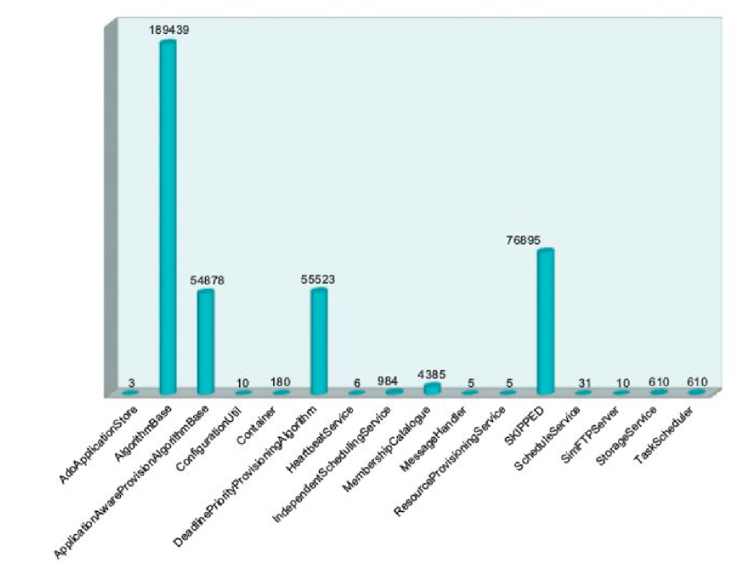
Figure 4.12: Component entry distribution
The two graphs show that there is a considerable amount of unstructured information in the log files produced by the Container processes. In particular, about 60% of the log content is skipped during the classification. This content is more likely due to the result of stack trace dumps into the log file, which produces as a result of ERROR and WARN entries a sequence of lines that are not recognized.
Figure 4.13 shows the distribution among the components that use the logging APIs. This distribution is computed over the data recognized as a valid log entry, and the graph shows that just about 20% of these entries have not been recognized by the parser implemented in the map function. We can then infer that the meaningful information extracted from the log analysis constitutes about 32% (80% of 40% of the total lines parsed) of the entire log data.

